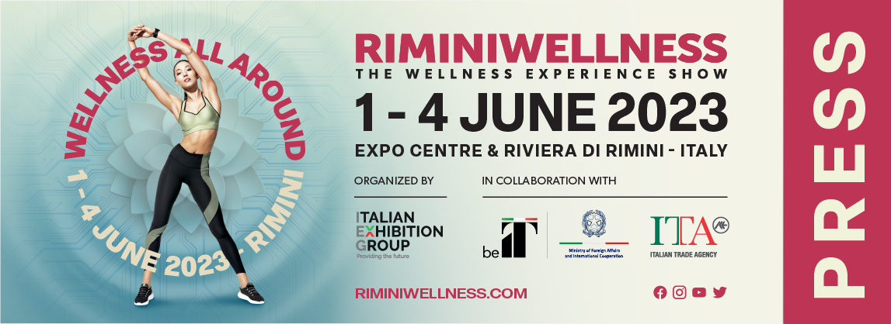

press release no. 2
English translation

RIMINIWELLNESS 2023: A THOUSAND APPOINTMENTS FOR ONE BIG EVENT

- Organised by Italian Exhibition Group, from 1st to 4th June 2023, Europe's leading event dedicated to fitness, wellness and sport will be staged at Rimini Expo Centre with numerous new features and visuals
- The first edition of the States General of Fitness and Wellness; an Advisory Board and WeSportUp, the new innovation accelerator

Rimini, 9th February 2023 – Like its loyal fans, RiminiWellness never stops and continues to innovate. For the 2023 edition, from 1st to 4th June at Rimini Expo Centre and on the Riviera, the IEG - Italian Exhibition Group event has numerous new ideas in store, all highly engaging and able to satisfy every need for training and furthering knowledge.

THE FIRST EDITION OF THE STATES GENERAL OF FITNESS AND WELLNESS

The opening day of RiminiWellness 2023 will see the first edition of the States General of Fitness and Wellness. Thanks to the involvement of all the sector's strategic stakeholders and its key themes, Rimini will be the place to be for all the industry's protagonists. Moreover, starting with this new edition, RiminiWellness will also boast an Advisory Board made up of professionals, institutions and partners to develop the themes of Health, Training, Innovation and the event’s Internationalisation.

GREAT PARTNERS FOR A BIG TRAINING PROJECT

To present authoritative training contents in order to build an indispensable moment for those who want recognised professional fitness & wellness training in Italy and Europe. With this aim in mind, RiminiWellness 2023, in collaboration with prestigious partners including Sport e Salute, 24 Ore Business School, Europe Active, Bologna University’s Department of Science for the Quality of Life - Rimini Campus, and other national universities, will be introducing a large variety of initiatives to provide training for the operator community.

INNOVATION IDEAS

Developed with Sport e Salute, the INNOVATION IDEAS area will present the WeSportUP project, the first innovation accelerator dedicated to sport and wellness, part of CDP Venture Capital's national network of accelerators, which in research and collaboration with the best global start-ups and scale-ups, has brought companies, institutions and investors on board: the new start-ups that will be presenting themselves to companies at RiminiWellness with pitches and speed meetings.

THE NEW RIMINIWELLNESS IMAGE

“The Wellness Experience Show”: RiminiWellness is an experience with the same circularity and balance as a healthy lifestyle. A show that places the person at the centre of the wellness system, sensationalising and, at the same time, spreading the culture of wellness and representing all its various aspects. The colours: sky blue fading into sand recalls the sea, Rimini, the Riviera; energetic and vibrant Viva Magenta is a symbol of rebirth in the post-pandemic era.

ABOUT RIMINIWELLNESS 2023
Dates: 1-4 June 2023; event: international trade show; organization: Italian Exhibition Group S.p.A.; frequency: annual; edition: 17th; entry: public and trade; info: www.riminiwellness.com

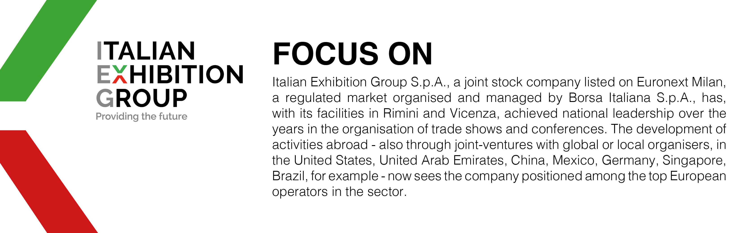

PRESS CONTACT ITALIAN EXHIBITION GROUP
head of corporate communication & media relation: Elisabetta Vitali |
press office manager: Marco Forcellini | press office specialist: Luca Paganin |
international press office coordinator: Silvia Giorgi |
media@iegexpo.it

MEDIA AGENCY RIMINIWELLNESS
Naper Multimedia| Zoe Perna | T. +39 02 97699600 | staff@napermultimedia.it

This press release contains forecast elements and estimates that reflect the management’s current opinions (“forward-looking statements”), particularly regarding future management performance, realization of investments, cash flow trends and the evolution of the financial structure. For their very nature, forward-looking statements have a component of risk and uncertainty, as they depend on the occurrence of future events. The effective results may differ (even significantly) from those announced, due to numerous factors, including, only by way of example: food service market and tourist flow trends in Italy, gold and jewellery market trends, green economy market trends; the evolution of raw material prices; general macroeconomic conditions; geopolitical factors and evolutions in the legislative framework. Moreover, the information contained in this release, does not claim to be complete, and has not been verified by independent third parties. Forecasts, estimates and objectives contained herein are based on the information available to the Company as at the date of this release.

